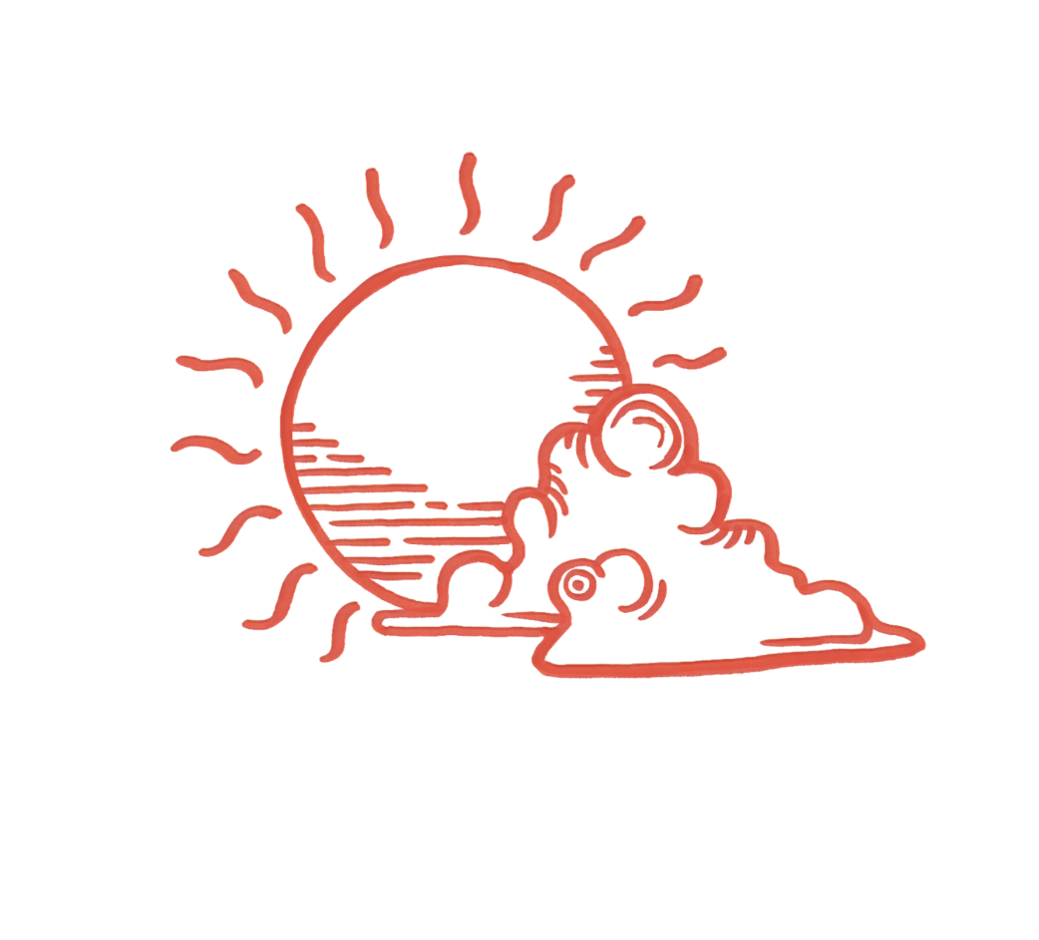
The Ninth Cloud LLC

612 Ocean Avenue,
Brooklyn NY 11226
www.theninthcloud.net

Lesson Policies
Cancellation Policies:
- Cancellation of the lesson must be made at least 24 hours prior to the scheduled lesson time in order to receive a make-up lesson. This includes calling, texting, and emailing teachers directly.
- No shows or failure to notify the teacher at least 24 hours ahead of time will be considered a forfeited lesson and the family is responsible to pay for the class.
- In case of emergencies, such as unexpected illness, accidents, Acts of God, canceled lessons will not be considered forfeited if they communicated with teachers right away.
- If you know the dates ahead of time where students will not be able to attend the class, please notify your teacher.
- Teachers are expected to follow the same guidelines and need to communicate their cancellations and time changes with families 24 hours ahead of scheduled lesson.
- If a teacher is late for classes or does not communicate about missing classes, families should inform The Ninth Cloud team at info@theninthcloud.net and are free to request a different teacher.

Make-up Lessons:
- Any lessons canceled 24 hours ahead of the scheduled lesson will receive a make-up lesson at a time convenient to both the teacher and the student. In some cases, due to students and teachers busy schedules, the make-up time can be added before/after the original lesson time.
- A make-up lesson can be booked with your teacher directly.

Both families and teachers should view their scheduled classes as contracted time and instruction on which the parent, student and the teacher can rely to be consistent.
Families and teachers should have an open line of communication and an ongoing dialog about scheduling, progress, and goals.
These guidelines will ensure quality and consistent lessons each month.

